As an addition to this project, we are adding techniques for processing and cleaning sensor data so that we don't have to pay extra for storage and processing when we get bad or corrupted data. Because of attacks or problems, sensors may sometimes produce corrupted data, and it can cost a lot to process and store this data. In almost every field, sensors are used to collect data. For example, in health care, sensors will be implanted in patients and send data collected to a hospital server to be processed. This processing includes running a complicated algorithm to encrypt the data and then storing it. The storage space and processing power will be wasted if we work with damaged data. So, before we process that kind of data, we will find it and get rid of it.

So, in health care, for example, the sensor has to be able to read body temperature between 10 and 105. If it reads something else, we will drop it. We can save money on storage and processing by using this method.

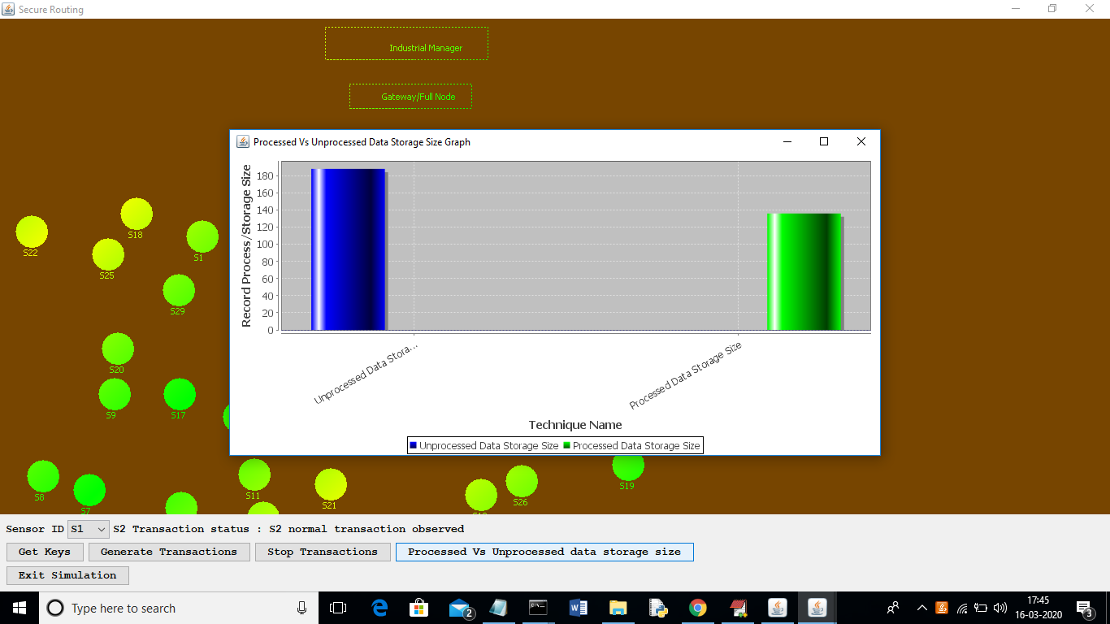

In the above graph, I'm getting rid of data that isn't related while sensing it, which lowers the cost of storage. The x-axis in the above graph shows the cost of storing all data and process data that is not related, and the y-axis shows the size. Based on the graph above, we can say that process data can lower both costs.

In this project, I'm also looking at values between 0 and 150 as valid sense data. Values above 150 will be thrown out as irrelevant data.